Proxy Leader’s Spark Cluster

# Purpose

Port forward from the leader’s spark cluster job queue to your home computer

# How-To

1. Login to Datahub and select a CSE255 instance
2. Open a Jupyter Terminal
3. SSH to dsmlp-login.
   1. ssh <username>@dsmlp-login
   2. ssh myusername@dsmlp-login
4. Clone the directory <https://github.com/ucsd-ets/dsc291-spark-cluster>
   1. git clone <https://github.com/ucsd-ets/dsc291-spark-cluster>
5. Change into the directory
   1. cd dsc291-spark-cluster
6. Run the proxy-spark.sh command supply the leader’s username
   1. ./proxy-spark.sh <username>
   2. ./proxy-spark.sh myleadersusername
7. Open a **local terminal** on your PC
8. Copy the SSH command from Step 3 onto your clipboard
   1. 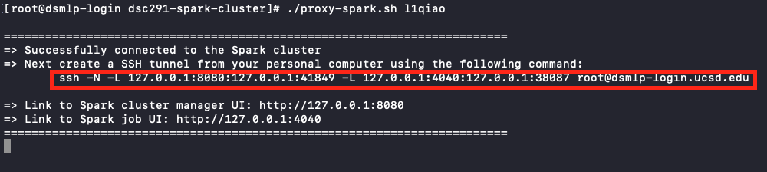
9. Paste the SSH output into your **local terminal** on your PC. Input your password and keep **this terminal session open for the duration of the proxy session**.
10. Open a browser and navigate to <http://127.0.0.1:8080>